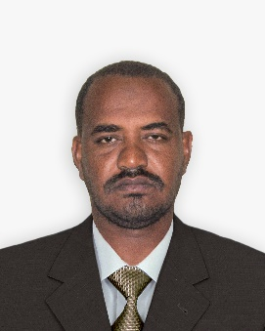
AHMED HUSSAIN MOHAMMED ALHASSAN
KHARTOUM, SUDAN
+249-912362107
ahmwaw@gmail.com

Info:
Date of Birth: 1st Aug. 1982.
Marital status: Married.
Nationality: Sudanese.

Education:
- Three years diploma in civil engineering - Sudan University for science and technology (2004).
- 12 years Secondary School Certificate.

Work experience:
Khartoum Refinery Co. Sudan, Khartoum north.
RFCC Operator: August 2008 – up to date.
Job title: Panel operator in Turbines and Compressors post.
Responsibilities:
- Turbines and Compressors start up and shutdown.
- Turbines and Compressors monitoring and operating.
- Conducts patrol inspections on time and performs required inspections during abnormal circumstances and report findings to the direct supervisor.
- Carrying out equipment’s normal operation, shut down, start-up and emergency shut down from the Control room as per process card and prescribed plans.
- Inspecting and monitoring of various equipment in the field and listens for automated warning signals/abnormal sounds to determine location and nature of any malfunctions.
- Hand-over equipment for maintenance after isolation and taking over from maintenance after repair then normalization.
- Maintains proper quality and quantity of lubrication for all rotating equipment.
- Add chemicals, takes routine samples for laboratory and the other routine activities.
- Checks all pressure/temperature gages, sight glasses, flow meters readings from field and communicate with panel operator for cross-checking.
- Act as standby/fire or additional watch man if necessary during critical operations and/or repairs.

Training:
- Basic operation course for equipment & process in Khartoum refinery Training Center.
- On job operation course for Process refinery in training center of Khartoum Refinery Co.
- Fire Fighting Training in Khartoum Refinery Co. HSE Department followed with regular refreshment courses.
- First Aid course in Sudanese Red Crescent.
- Process Safety Management in in training center of Khartoum Refinery Co.
- Abnormal Situation Management course from SAGA Global Consultant - India.

Skills:
- Ability of working and interacting with different people within different nationalities.
- Speaking English very good, and studying four levels in French.
- Friendly, team worker, active, creative, co-operative, work under pressure.

