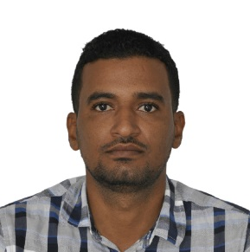

Date of birth : 1989
Place of birth : Omdurman -Khartoum
Gender : male
Nationality : Sudanese
Marital status: Married

- Bachelor's Degree, Telecommunications Engineering
Almanhal Academic of Science.

- Ericsson IRA&IRC
- Risk Assessment Training Program
- EHS Safety (Huawei)
- First Aid
- Fire Fighting

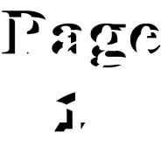
Sable Telecom Solutions from 4/8/2014 till 20/5/2016
- Omniacom Libya from 26/5/2016 till 30/11/2018
- Abuabid from 23/7/2019 till now

- Ericsson 2G Network Installation& commissioning (2000&6000 family)
- Ericsson 3G Network Installation& commissioning (DUW,U900)
- Ericsson 4G Network Installation& commissioning (DUS, TCU,SIU,Base Band)
- Ericsson Traffic Node (20p, 6p, 2p,CN500, CN510) Installation& commissioning
- Installation of Battery Backup Systems (PBC 6500, PBC 6200. PBS 6102, BBU(
- Ericsson IBS Solutions Systems Installation
- Huawei BTS 3900 series (2G, 3G, 4G) Installation
- Huawei RTN950, RTN980, RTN910,RTN370 Installation& commissioning
- Alignment microwave 0.3, 06,0.9(Ericsson, Huawei)
- Installation& commissioning Microwave XPIC (Huawei&Ericsson)
- Site survey (RADIO&Microwave)
- Installation Nokia equipment (nodeB,RFM)

- ISDP mobile (Huawei)
- SDE mobile(Ericsson)
- SRS (Ericsson)
- MDT&WDT
- Mini Link Craft
- OMT
- RBS Element Manager
- Moshell
- Smart LapTop

- Ability to work with Group
- Ability to manage teams
- Ability to work under pressure

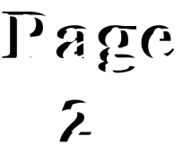
https://www.linkedin.com/in/mohamed-salah-30483277

