SIFELDAWLA ALAMEN OSMAN YOUSIF
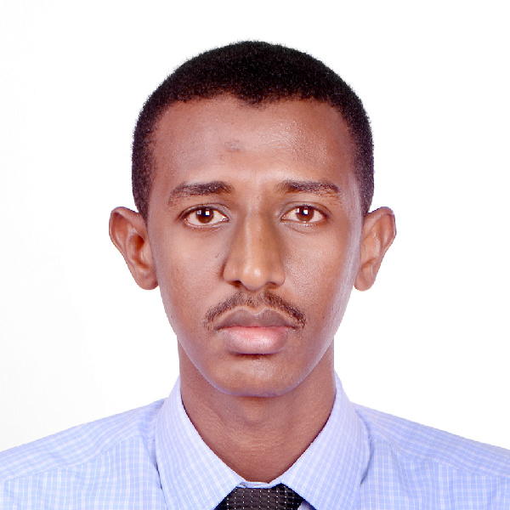
+971505489822
safeeldawla@yahoo.com

PERSONAL STATEMENT
I am an experienced Statistician with over four years’ experience in data entering and interpreting, comprehensive analyzing, and megaprojects surveying. Working with an array of prominent research experts and pioneers, has fostered my profound understanding of using statistical tools and methodologies; Specially in the adaptation of conducting, sampling, and validation of the research studies. Therefore, my intensive experience and wide accumulative knowledge, enhanced the progress of cultivating a broad understanding of statistical concepts, methods, and models.
Accordingly, I have thoroughly obtained a complete and distinguish set of skills of using computer applications.
Hence, I have the confidence that I will be an outstanding contribution to the Company in meeting its objectives.
PERSONAL INFORMATION
Sex : Male
Nationality : Sudanese
Year of Birth : 04 January 1989
Marital Status : Single
Driving License: Valid UAE Driving License (Abu Dhabi)
Holding Transferable Residence Permit in the UAE
LANGUAGES
▪ Arabic (mother’s tongue): Fluent [reading, writing and speaking]
▪ English: Excellent [reading, writing and speaking]
EDUCATION
▪ September 2013 - BA with honor’s in Applied Statistics – Sudan University of Science & Technology – Khartoum, Sudan
▪ March 2009 - High Secondary Certificate –New Halfa Secondary
School -New Halfa – Sudan

TRAINING & CERTIFICATIONS
- February 2017 – Academic IELTS (International English Language Testing System).
- February 2016 - Statistical Researcher – Statistical Training Institute – Abu Dhabi – UAE.
- Microsoft Windows & Microsoft Office
SKILLS & COMPETENCIES
- Ability to manage numerical data.
- Ability to perform statistical analysis, including description, dimensional reduction and linear models.
- Ability to format and present results, including clear interpretations and charts.
- Ability to manage time and resources, work independently, and pay attention to detail.
- Ability to communicate clearly, works in a collaborative environment, and learn and apply new skills in the context of a fast-paced organizational agenda and ambitious organizational objectives.
- Desire to work cross-disciplinarily and to incorporate suggestions from a wide array of colleagues.
- Ability to perform academic research
- Adaptability to a rapidly changing in work environment
- Multi-tasking skills& fast learner.
- Proficiency with SPSS and Minitab(Statistical software programs)
- Multivariate statistical methods
- Excellent knowledge of statistical packages
- Adequate knowledge of data collection methods (polls, focus groups, surveys etc.)
WORK EXPERIENCES
(28 November 2017 – Present) Head Chief Officer of Dubai Office at Taqieem Trade Information Center
Job’s Responsibilities:
- Responsible for monitoring the teams of Dubai Branch in the project of business and ventures assessment which is initiated by The Ministry of Human Recourses and Emiratization.
- moderating and organizing the daily tasks for more than 20 team with a human capital exceeded 100 assessment operator.
- Advising on the Direction of the work for the other beaches in the United Arab Emirates.
- supervising each operational department, likewise designing the strategic and implementing plans of them.
- solving the obstacles that encountering the project and fulfilled an outstanding satisfactory and efficiency records in the organization.
- Communicating and implementing a company's strategy internally and externally so that all employees, partners, suppliers, and contractors understand the company-wide strategic plan and how it carries out the company's overall goals.
- Driving decision-making that creates medium- and long-term improvement.
- Developing inclusive planning processes.
- Design opinion polls, and social surveys.

(May 2014-August 2017) Statistics Center, Abu Dhabi, UAE
A Statistical Analyst& Field Surveys Supervisor
Job’s responsibilities:
•Develop and conduct statistical surveys by designing data collection instruments, calculating sample sizes and selecting appropriate analytical procedures.
•Conduct data analyses, and report results associated with a research study, using SPSS, Minitab, and other statistical analysis software.
•Summarize statistical results of a research project by creating graphs, tables and charts. Interpret and convey results to project leaders, principal investigators and/or outside agencies. Refine statistical models after consultation.
•Design ad hoc reports requested by administrators, for example an analysis of client workday and income data, the tabulation of gender and race/ethnicity of populations served, and comparison of study data with similar data from other institutions.
•Advises other Statistical Analysts and principal investigators on the most appropriate statistical techniques to be used in particular projects.
Other roles in Statistics Abu Dhabi
- Statistics Center, Abu Dhabi, UAE (May 2014-till October 2014).
An enumerator (researcher) in the economic survey
- Statistics Center, Abu Dhabi, UAE (April 2015-till August)
A supervisor in the Economic Survey
- Statistics Center, Abu Dhabi, UAE (September 2015-till October)
A controller in the occupational safety and health survey
- Statistics Center, Abu Dhabi, UAE (October 2015-till December)
A controller in the Labor Force Survey
- Statistics Center, Abu Dhabi, UAE (March 2016-till June)
A supervisor in the Economic Survey
- Statistics Center, Abu Dhabi, UAE (July 2016-till August)
A controller in the Free Zone Survey
- Statistics Center, Abu Dhabi, UAE (September 2016-till January 2017)
Field Surveys Supervisor in the National Survey for Happiness & Positivity
REFERENCES
Available upon request

