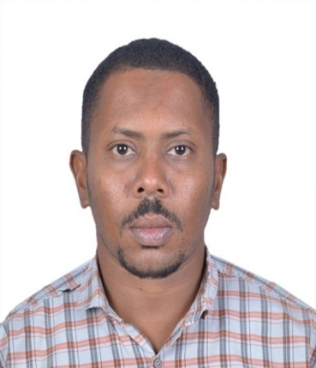
Curriculum Vitae “CV”
MOHAMED HABEEB SIDDIG HABEEB
Email: habeebko1900@gmail.com
Mobile: 00249912507785, 00249922277393, 00249122706390

Instrument senior technician
Over 10 Years of Experience in Refining and Petrochemical Industry
- Installation, Calibration, Maintenance, Configuration,
Troubleshooting, Loop Checking and Plant Commissioning.

- Career Objective : To obtain position that will utilize my skills and let me continuously update my knowledge in instrumentation.

- Professional Goals : My long-term goals are towards making a positive impact in the company through my expertise and ethics. I also look forward to develop myself in leadership areas through experience and training offered by the company.

- SUMMARY :-
Profile : Male, 15, November, 1987, marriage .
Nationality : Sudanese.
Driving license : Available.
Current location : Sudan/ Khartoum.
Current Position : Instrument senior technician
Current employer : Khartoum Refinery Company.
Salary expected : Not specified/ Negotiable.

- Work Experience:-

- Khartoum Refinery Company :-
15/7/2012 - Present Khartoum- Sudan
This company is active in oil & gas and distributed the products all over the Sudan.
Iam responsible for: -
- Manages others and delegates tasks as well as reports to upper-level management regarding such things as new equipment, and problems with current instrumentation
- Field & Bench Calibration of all process Instruments (Transmitters, Control Valves, and Switches …. etc.).
- Loop checking & Fault finding and rectification for instrumentation system.
- Preparing technical reports as required.

- Trainer new employees (As Instructor) : -
- Field instruments measurements such as flow, pressure, level, temperature and include (Transmitters, Control Valves, and Switches ….etc).
- Highlights: -
- Good Experience in Process measurement & Instrumentation like installing, configuring and maintenance of all refinery instruments (Transmitters, Control valves, switches ... etc.
- Good Knowledge about plant safety precautions and Permit to work systems.
- Good Experience in plant Maintenance& Commissioning.
- Participate in KRC Overhauls 2013, 2015, 2017 and 2019.
- Participate in Instrument Section Duty and Technical support in official holidays.
- Participate in Khartoum Refinery Sudanization Program for Instrument Technicians.

- Education: -

- The Jordanian Sudanese College of Science and Technology- Specialization Bachelor's (BSc) degree in Control Engineering 2020.

- Sudan University of Science and Technology - Faculty of Technology - Department of Engineering Studies - Specialization Diploma in Electronics Engineering (Communications)2009.
- Diploma in computer network from 20/12/2011 to 21/3/2012.
- Courses: -

- Training in Khartoum Refinery Company LTD (Instrument section) since 15/7/2012 to 15/7/2014.
- Training in ministry of science & technology on computer from 1/11/2009 to 1/11/2011.
- Basic of hydraulic systems Course in Zeta Automation Systems Training Center from 28/7/2018 to 5/8/2018.
- Electro hydraulic systems Course in Zeta Automation Systems Training Center from 6/8/2018 to 11/8/2018.
- The use of radioactive sources and radioactive material and prevention of the danger of ionizing radiation in egypt from 11/11/2019 to2/12/2019
IT Skills:

- Windows & Office tools
- MS Word & Excel
- Good in maintenance of computer (software)
- Skills:

- Instrumentation field

- Languages: -
- Arabic Native
- English Fluent

- References:-

- Habeeb Siddig Habeeb TEL +249923719069.
- Mohamed Ibrahim Yasref company.
Instrument Instructor
mohamedsidahmed@gmail.com phone +966535064146

- Ali salih M. Saber Khartoum Refinery Co.
Instrumentation Head Section
asalihsabir@krcsd.com phone +249912330719

- Omer Abdurrahman Qapco Company.
Instrument / control Engineer
Omer478@hotmail.com phone +97466042511

