بسم الله الرحمن الرحيم
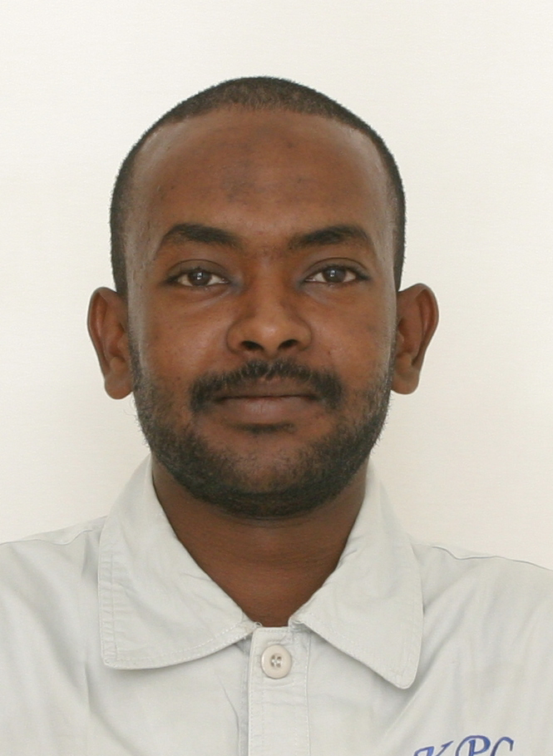
Curriculum Vitae of: Adil Osman Elnafi Mohamed Ahmed

Personal Data:

Date of birth | 27/ 05/ 1984
Place of birth | Khartoum - Sudan
Gender | Single
Nationality | Sudanese
Religion | Islam
Marital statues | married
National service | Released
Current address | Sudan-Khartoum-
Mobile | 00249918627623 / 00249928463068/ 00249112042634
E-mail | adolaaa84@Hotmailcom – adolaaa84@gimail.com

Objective:

To seek a challenging job to gain personal and working experience that will allow me to grow in my career and reach a leadership positions.

Qualifications:

Chemical Engineer - Major Refining (Diploma)

Training courses:

- Safety course in firefighting and emergency control in Khartoum Refinery Company K.R.C In 2010.

- Courses in Khartoum Petrochemical Company K.P.C in:-

- Mechanical equipment.
- Using & Care of Personal Protective Equipment.
- Emergency control.
- ISO and quality control course.
- Fire Prevention Engineer.
- Hazard identification.
- Work permits tips.

- Employ in Khartoum Petrochemical Company (KPC) From (10/03/2008) Until Now.
- Internal and oversea training courses in CHINA PEOPLE REPUBLIC in Lan Zhou &
- Risk assessment Terhniques developed and present by DNV ACADEMY sudan 15,16,17 october2
- Training course in effective administrative supervision and reporting. Astico traning institute from 21/04/2019 to 25/04/2019. Khartoum

Experiences:

Total of 6 years in Oil and Gas industries as follows:

Worked in Khartoum Petrochemical Company K.P.C. (Polyolefin plant) from the tenth of JUN 2010 to the first of APR 2014 in a various divisions:

Responsibilities and duties:-

- Carry out procedure of safety responsibilities of packing operator.
- Carry out take-over hand-over procedure with former and successor packing operators.
- Check sanitation situation of packing area.
- Check automatic balances.
- Check digital balances (accuracy, charger).
- Check sewing machines (electric cable, oil, needle, etc.)
- Check forklifts (keys, tires, oils, batteries).
- Check printing machine (electric cable, ink, etc.).
- Check remains of powder sample at first floor of polymerization unit.
- Control standard weight.
- Immediately report the shift monitor about any abnormal phenomena.
- Prepare printing machine for your shift (shift product number code).
- Operate the forklift carefully and in safely speed.
- Coordinate with granulation chief operator feed stabilizers and antioxidants.
- Manage labors shifts, let them be responsibly, carefully and safely work.
- Sort and store product plates at required place.
- Coordinate with marketing staff to help them load product and check weight safely and smoothly.
- Write down operation reports, consignment sheet, and packing quantities and check weight record.

- Field operator at the Polymerization unit feeding & out feeding operator (poly propylene plant) from 01/03/2008 to 1/05/2009.

Responsibilities and duties:-

- Carry out procedure of safety responsibilities of polymerization field operator.
- Carry out take-over hand-over procedure with former and successor polymerization field operators.
- Control operation situation of all propylene feeding pumps.
- Control operation situation of all injector pumps, cooling water pumps, hot water pumps, vacuum pumps and white oil pump.
- Control material feed record as required: AT, DDS, CS, DQ, white oil.
- Perform operation inspection check.
- Keep all equipments and machines in a good running condition.
- Immediately report the shift monitor about any abnormal phenomena.
- Report LPG record, C4 gas and propane gas.
- Change activation agent tank with other operators.
- Immediately report the shift monitor about any abnormal phenomena.

- Field operator & Shift Supervisors at the Distillation Unit (poly propylene plant) from 1/05/2009 to 25/02/2012.

Responsibilities and duties:-

- Carry out procedure of safety responsibilities of gas distillation field operator.
- Carry out take-over hand-over procedure with former and successor gas distillation field operators.
- Check all DCS graphic parameters and make a confirmation with the local parameters at distillation unit.
- Check operation situation of distillation pumps.
- Perform operation inspection check.
- Write down operation reports and records (stabilizing agent record).
- Check and inspect work situation of spherical tanks and associated pumps.
- Operate low recovery system reciprocating compressors.
- Supervise production line operation in accordance with plant policies and procedures.
- Conduct employee performance reviews.
- Coordinate production start-ups, shutdowns, and changeovers.
- Schedule and conduct shift meetings.
- Responsible for quality control. Make adjustments as necessary during shift to produce product within specifications.
- Operate within standard operating procedures (SOPs) and Job Safety Analysis (JSAs).
- Communicate with other Shift Supervisors and Plant Manager.
- Keep all equipment's and machines in a good running condition.
- Keep work area cleaned.
- Immediately report the shift monitor about any abnormal phenomena.

- DCS panel operator at Polymerization & Distillation Unit from 25/02/2012 to 31/03/2014.

- Distillation Unit

Responsibilities and duties:-

- Carry out procedure of safety responsibilities of chief operator for gas distillation of PP DCS.
- Carry out take-over hand-over procedure with former and successor monitors.
- Read former reports and records, check if any notes written.
- Check operation situation of all equipment devices and facilities radiotelephone (battery, charger).
- Operate distillation unit strictly.
- Try to decrease consumption and keep steady operation at propylene columns in high purity and high yield rate.
- Any other work requested by production department.

- Polymerization Unit

Responsibilities and duties:-

- Carry out procedure of safety responsibilities of chief operator for gas distillation of PP DCS.
- Carry out take-over hand-over procedure with former and successor monitors.
- Read former reports and records, check if any notes written.
- Check operation situation of all equipment devices and facilities radiotelephone (battery, charger).
- Check the staff attendance.
- Check safety protection facilities.
- Operate Polymerization Unit strictly.
- Operate the DCS – system correctly and safely.
- Carefully protect all the hardware of the DSC- system.
- Give right instruction to polymerization field operators, correct and clear information to other operators (lab. Analyst, granulation chief operator, packing operator and so…
- Contact with granulation chief operator to transfer PP powder via transportation system into the pressing and granulating process.
- Any other instructions requested by production department.

Achievements:

- As a token of appreciation towards my outstanding achievements and contribution to the company in year2013, I have been selected as an excellent staff member for Khartoum petrochemical Co., Ltd.

- The first level of safety suggestion Award in 2014 from K.P.C Khartoum petrochemical Co., Ltd.

- Working with high performance and without any mistakes or warning letter for all the experience I have.

Skills:

- Computer: good in computer application, internet, programming language and designing software.
- Well-developed communication skills: demonstrated in Arabic and English, documented writing and editing talent.
- Ability to work well independently or as part of a team. Possess ability to adapt rapidly to any kind of work regardless of the work condition.
- Willing to travel.
- Sudan Driving license.
- Passport no, p06286463

References:

Mr. Omer Mamoon Mr. Mohammed Adam Mohammed
K.P.C Production manager Nile Petroleum Company.
Phone No: 00249912155406. Phone No: 00249123322877.
Email: omermamoon@gmail.com Email: abuayman71@hotmail.com

