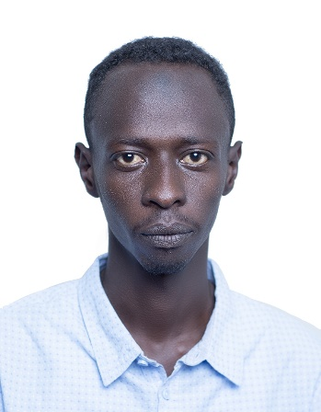
MOSAB SALH OSMAN EBRAHEM

Khartoum, Sudan.
Email address: mosab1@outlook.com
Mobile number: +249922746161

Personal Details

Date of Birth: 22 April 1993
Gender: Male
Civil status: Single
Nationality: Sudanese
Spoken Languages: Arabic (Native), English fluent

My years of work experience in Sudan in the IT industrial and customer service, that have provided me the opportunities to develop into a productive career oriented individual. I have experience working within corporate and multi-cultural Organizations and liaising with staff at different levels in the company. My main qualities such as being hard working and determined assists me in achieving the company’s goals and also any individual targets and goals set by my manager. In all cases I always ensure I am an asset to the company and ensure I give my best in all I do at all times.

Key Skills:

- Excellent communication skills both oral and written.
- Proactive and Customer service oriented.
- Good listener and very patient.
- Able to communicate effectively at all levels.
- Computer literacy and computer skills.
- Ability to multi-task.
- An excellent team player and one who creates a good working environment.
- Highly organized, punctual and flexible.

Experiences

November 2019 - present: IT Executive at Aramex International

- implementing database and network designs.
- installing and upgrading software.
- office 2016,2019 and 365 installation and troubleshooting issues.
- Weekly backup data using Backup Exec.
- ensuring systems security and troubleshooting computer issues throughout their organizations.
- coordinating software implementation and upgrades.
- determining IT budget and equipment needs.
- Troubleshooting and solving Printers and Scanner problems.
- Installing and maintain computer hardware and software.
- Managing windows servers, and database.
- Configuring the AVAYA system by create, edit, updating and installing extensions.
- System admin for Queue Metric, FreePBX and others systems.

February 2019 November 2019: Customer Service Representative at EBS (Electronic banking services Sudan)

- Receiving inbound calls from the customers
- Analyzing the customer issues regarding their ATM card and ATM machines.
- Providing the solution to their problems in a short time.
- Keep records of all conversation in our call center database in a comprehensible way.

April 2018 – October 2018: Customer Service Representative (at AAA for Rafid accident unit)

- Receiving inbound calls from the customers
- Identify customers’ needs, clarify information research every issue and provide solutions
- Provide the driver with the customer location and information
- Keep records of all conversation in our call center database in a comprehensible way.
- Providing the customer with the information that they need.

December 2015 –March 2016: Training as a network support at university (Sudan)

- Installing and configuring new networks at the university campus
- Installing and maintain computer hardware and software
- Troubleshooting and repairing basic Network problems
- Troubleshooting and solving Printers and Scanner problems
- Connect patch cables between switches cabinet and P/Cs

Mobile software technique (Sudan) as apart time job

- Identifying the mobile problems weather, it’s a software problem or hardware.
- Informing the customer about the cost.
- With the use of the software application making a backup for the data of the device.
- Identifying the android version of the device
- Solving network problems.
- IME problems.
- Camera and all the problems that related to the software issues.

EDUCATION

- 2015 Bachelors of Computer Application from Bangalore University (India)

- Diploma of computer hardware A+

- MCSA

- Cyber Security essential

- CCNA Certified

- Linux Red Hate

DECLARATION:

I hereby declare that all the information’s given above are true to my knowledge.

Mobile number: +249922746161

References: Available Upon Request

Name: Mosab

