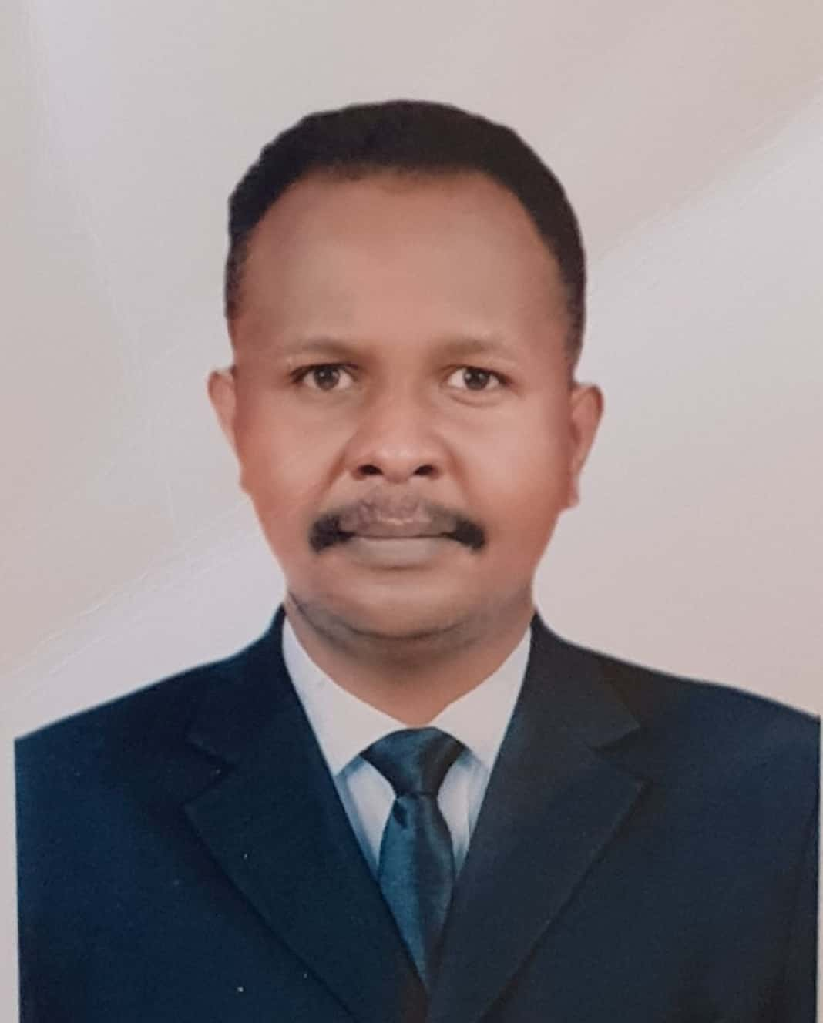
Hatim Mirghani Mokhtar Mohammed
Seeks a general surgeon job.

Khartoum, Sudan hatoma77@gmail.com Male, single, Muslim

00249912447545 Sudanese Nationality 29th April 1989, Elgolid, Sudan

Profile

A dedicated and hard-working Doctor, seeking to work within General Surgery, with a particular leaning towards supporting complex cases that require strong pre-to-post care. Has held five years training program between general,orthopedic, plastic,urolgy, paediatric and emergency surgery, both in support of senior surgeons and autonomously in managing major and minor procedures and casework.

Brings a high learning ability, strong communication skills and ambition to achieve rapid progression. Seeks to blend learning with leadership opportunities, and built on a robust foundation of five years as surgical risdent and two years as Medical Officer. Skilled at providing immediate care, and working with senior doctors to handle complex patients.

Key Skills

- Adept at supporting both inpatient and outpatient-based surgical clinics and theatre sessions for general surgical cases, including more complex cases found in HDU and Intensive Care settings
- Provides cover to Emergency Surgery, including for poly-trauma victims, demonstrates a well-structured approach and effective leadership of SHO’s, HO’s, Physician Associates and Nursing Teams
- Demonstrates skill in performing Laparoscopic and open surgeries.
- Adept at the full pre-peri-post surgical processes, able to support patients throughout the process, and demonstrating the ability to build trusted patient relationships
- Mentors and coaches junior colleagues, , with an assured leadership style
- Demonstrates strong communication with clinical and administrative teams
- Contributes to audit and research functions, including the development of new policies, processes and approaches to surgical intervention, infection control and wound management

Memberships

 | Sudan Medical Council | 2020
 | SMC Licence to Practice specialist general surgery #1046
 | Royal College of Surgeons, UK | 2015
 | Full Membership

Education

 | Sudan Medical Specailization Board | 2020
 | MD of General Surgery
 | Omdurman Islamic University | 2011
 | Bachelor of Medicine and Surgery

Certifications and courses

Sudan Association of Surgeons
The basic surgical skills course 2016
The severe truama instruction course 2017
Sudan Medical Specialization Board
Research and Methodolgy 2017
Khartoum North Laproscopic Surgery Training Center

Basic laproscopy training 2018

Career History

 | Ombada Teaching Hospital | Dec 2020 – Present
 | Specialist General Surgery | Omdurman, Sudan

responsibilities
- Supports A&E as an on-call Surgical Consult
- Practices within the, Male and Female Surgical, Adult ICU surgical wards.
- Perform emergency and elective general surgical operations.
- Has managed poly-trauma victims at A&E and in-surgery in line with ALTS protocols
- Performs major and minor surgical procedures as the lead surgeon, with ultimate responsibility for patient health
- Mentors and teaches junior doctors as a part of their surgical rotation, and in general surgical functions
- Conducts weekly general surgery OPD

 | Sudan Medical specialization Board | Martch 2015 – Martch 2020
 | Registrar General Surgery | Khartoum, Sudan

Sudan Medical Specialization Board is the sole professional training body in the Republic of the Sudan mandated to manage and deliver medical and health specialty programmers in the country.
- Conducted ward rounds across General Surgical units with a member of the healthcare team
- Conducted and presented siminars and tutorials .
- Evaluated patient health and wellbeing both pre and post-surgical procedure
- Provided both routine and emergency medical cover to A&E and urgent care units
- Supported High Dependency and Intensive Care Settings as a Surgical Consult when needed
- Assisted within theatre and observed procedures; gained experience in performing major and minor procedures
- Presented cases to senior surgeons following full work-up of patient history, health and current status
- Demonstrated a positive, patient-focused bed-manner to place patients and families at ease
- Administered intravenous medications and additional therapies as required, including through recovery

 | Omdurman Teaching Hospital | 2014 –2015
 | Medical Officer –Trauma | Khartoum, Sudan

 | Omdurman Military Hospital | 2013 –2014
 | Medical Officer – General Surgery | Khartoum, Sudan

 | Sudan MinIstry of Health | 2012 –2013
 | House Officer | Khartoum, Sudan

Additional Skills

- IT Skills: Excellent command of Microsoft Office (Word, Excel, PowerPoint, Outlook)

References

- Pro. Aamir Abdullahi Hamza , Senior Consultant General Surgeon, Omdurman Teaching Hospital , aamirhamzza@yahoo.co.uk
- Prof. Mohamed El-Makki Ahmed, president of SMSB, Senior Consultant General Surgeon, rasheid@usa.net

