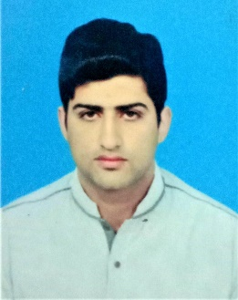
Professional Resume
Objective:

To serve at my professional best for the growth and prosperity of a highly competitive
Organization. Looking for technologically advanced and intellectually vibrant learning
Environment that motivates, deepen and advance the knowledge of the field.

Personal Information
Name | Sikandar Ali
Father Name | Syed Tariq Mahmoud
Date of birth | 06-12-1989
Address | House#22 g 637 pof wahcantt
NIC Number | 37406-7363127-7
Mobile Number | 92332-5437397 / 92311-5123765
E-Mail | Mtechnical61@gmail.com

Academic Qualification
Year | Degree | Institute | Division
2019 | B.TECH HONS MECHANICAL | COMEWAVE UNIVERSITY ISLAMABAD | 2.6 cgpa
2010 | DAE MECHANICAL | Punjab technical board education Lahore | 1st Division
2007 | Metric (Science) | Federal board Islamabad | 2nd Division

Professional Experience
Company | Designation | Duration
- (HAIDRI BEVERAGES) Pvt Ltd ISLAMABAD | OPREATOR TECHNICAN | One year From February 2013 to February 2014
- Qarshi industries pvt ltd Hattar Industrial state Haripur | Supervisor MECHANICAL | 6 Years from March 2014 to Present

*Working experience on SYMPAK (Italian Plant PLC Controlled) IN HAIDRI BEVRGES CANNING line.

*WORKING EXPERIENCE ON QARSHI JAM E SHREE PLANT, natural medicine plant, natural mineral water plant, ready to drink plant.

*OPREATION operator of (SHRINKWRAP, DE PELATIZER, PALATIZER, FILLER) in haidri beverages

*Maintenance BY HAND SKILLS all type of gearboxes, pumps, bearings

* Pumps maintenance of positive displacement pumps lobe pump, gear pump swash plate pump centrifugal pumps (single stage, open impeller, semi closed impeller, frame mounted and closed coupled pumps.

*Vast knowledge of gears spur gear helical gears worm wheel gears bevel gears.

*Vast knowledge of bearings and their types, bearing designation numbers.

Maintenance of gearboxes speed reducer gear boxes spur gearboxes helical gearboxes.

*Well experience in preventive and annual maintenances.

*software Sap Hanna s4 end user.

Extra Skills
Participate ISO 9001 , 14001 , HACCP , HALAL Training Sessions at Qarshi Industries Pvt ltd

Computer Course
English language course | 6 months from NUML Islamabad
Cnc milling and turning | 6 months From technical training institute Islamabad
AutoCAD | Computer center WAHCANTT

Languages
English
Urdu

