CURRICULUM VITAE
Personal Details
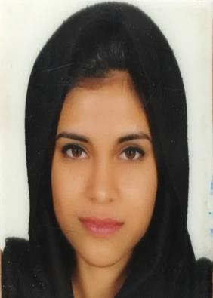
Name : Mehnaz Mohideen
Date of Birth : 27/08/1996
Age : 22
Gender : Female
Marital Status : Single
Nationality : Indian
Contact No : +249 995616442
Address : Arkaweet, balabl street, Khartoum
Email ID : mehnaz.mohiden27@gmail.com
Languages Known : English,Hindi,Urdu,Malayalam,Kannada.

Educational Background
2011 - Passed 10th from St. Lourdes high school, Bangalore, India.
2014 - Passed 12th from St. Joseph’s Pre-composite girls college, Madikeri, India.
2018 - Graduated from Future University, Khartoum, Sudan.
B.Sc. in Knowledge Management; faculty of Information Technology
-Attended classes for android application(basics).
-Basic computer knowledge.
Work Experience
Fresher.

Personal Skills
Ability to give my best in a team work as well as independently.
Eager to gain new knowledge.
Positive energy, ability to follow instructions and deliver quality results.

