Mohammed Ali Khalid
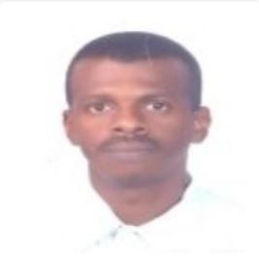
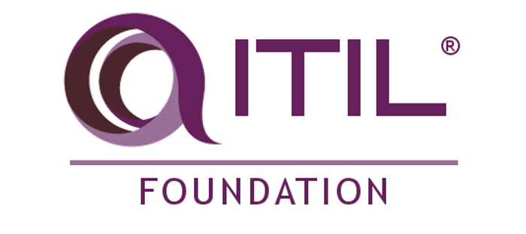
ElTayif Block 22 – House 77 – Khartoum - Sudan
Nationality: British - Sudanese
Mobile: +249912107265
mohammedali8899@yahoo.com

Personal statement

A multi-skilled IT Helpdesk manager with good all-around supervisory and technical expertise. Very capable with a proven ability to ensure the smooth running of ICT systems and to provide IT services that will improve the efficiency and performance of a company. Extensive practical knowledge of complex systems builds, hardware and software testing, network support, technical support and computer repairs.

Key Skills

- Information Systems Administration & Configuration. | - Budgeting & Cost Estimation.
- Computer Networks Administration (LAN/WAN/ Wireless). | - IT Contracts Administration - (SLA).
- Active Directory Administration. | - Problems Solving Skills.
- Project Management. | - Team Leadership & Time Management.
- Database Administration (SQL Server). | - Risk Management.

Employment History

Help Desk Manager, Central Trading Company - CTC Group - (DIGITECH)
Khartoum- SUDAN (June 2015 – Present)
Duties and responsibilities:
  - Responsible for plans, forecasts, and budgets developments for the IT department and monitor their implementation;
  - Manage IT projects and control the following: project scope, project deadlines, project resources and project budget.
  - Manage the Risk register and SWOT Analysis for the IT systems and operations.
  - Set operational KPIs for the department and ensures their implementation;
  - Monitor incident management database and follow up with assigned personnel to ensure timely resolution of problems, meeting operational Service Level Agreement requirements;
  - Develops IT tech schedules, prioritizes support calls and allocate resources for installation and support;
  - Creates and manages escalation procedures and ensures service levels are maintained;
  - Develop helpdesk standards, as well as research and procurement of relevant technology.
  - Develop and maintain department Standard Operating Procedures (SOPs)
  - Manage the IT assets records which include the machines details, general condition and the machine maintenance record.
  - Develop, manage and maintain reports for internal support teams and IT management to provide necessary issue status.
  - Documents and trains on all work performed.
  - Manage the Help Desk staff including performance evaluations, promotions, training, hiring and disciplinary responsibilities.

Business Support Specialist, Kenana Sugar Company/ Kenana Eng. & Tech. Services (KETS)
Khartoum- SUDAN (February 2012 – May 2015)
Duties and responsibilities:
  - Managing the delivery of Technical Support and Support services to all KETS staff.
  - Managing the Installation & configuration of the new IT systems and equipment.
  - Administration and Maintenance of company computer network (LAN).
  - Administration of the Active Directory, Domain Controller & Group Policy of company computer network.
  - Managing the delivery of Technical Support and Support services to all KETS staff
  - Implement Support Processes in line with the ITIL framework
  - Working closely with IT vendors to continue the enhanced service improvement across the company.
  - Translate KETS functional requirements into technical requirements
  - Collecting, understanding, and transmitting the business requirements for the project, and translating these into functional specifications and detailed test plans.
  - Provide the link between the KETS staff and any third party regarding software/hardware functionalities including IT network equipment.
  - Day to day management of change requests in relation to KETS IT applications.

Management Information Systems (MIS) Analyst, United Nations Development Program (UNDP) - DDR,
Khartoum - SUDAN (February 2011 – February 2012)
Duties and responsibilities:
- Implementation of ICT strategies and introduction/implementation of new technologies.
- Database Administration for the reintegration activities to X-combatants in the DDR program for 7 states in Sudan which include the following activities:
- Establish the counselling activities for the X-combatants each in their living state in Sudan.
- Create the necessary reports for the counselling numbers including the following statistics:
      - Number of X-combatants for each state
      - Gender percentage (Male – Female)
      - Disability percentage (Able- Disabled)
      - Reintegration package options
      - Living state matrix
- Ensure effective functioning of the project’s ICT programs.
- Ensures efficient networks/system administration.
- Provides administrative support, focusing on achievement of the following results:
    - Provide advice on and assistance in procurement of new ICT equipment for the project, provision of technical specifications and information on best options in both local and international markets, review of quotations and bids.
    - Train relevant staff in the use of database and front end application, define operational procedures and manuals, and assist with database applications and report generation
- Maintenance of a library of ICT related reference materials
- Ensures facilitation of knowledge building and knowledge sharing in the project
  - Coordinate with UNDP Implementing Partners (IP) for the final reintegration process for the X-combatants.
      - Collecting the reports from the Implementing Partners (IPs) and generate a consolidated report.
Network Manager, Africa Microchips Advanced Technology Services Co. Ltd (MATS)
Khartoum – SUDAN (August 2005– October 2009)
Duties and responsibilities:
- Administration of the company Local Area Network which include creating the employees accounts and managing their privileges in the network
- Administration of the Active Directory & Group Policy in the company LAN.
- Managing the exchange server.
- Management of the internet access and security procedures in the network.
- Provide Help Desk service to MATS’s employees.
- Planning the technical solutions and networks for the company’s clients.
- Installation and configuration of voice and data networks, setting up Telecom Devices for MATS’s clients.
- Provide Technical support to MATS’s Clients.
- Establishing the Negotiation and making the agreements with MATS clients.
- Managing the MATS projects.
- Planning the technical solutions and networks for MATS clients.

Education

University of Gezira – Khartoum - SUDAN
- MSc in Computer Science
(June 2006 – June 2008)
Future University (Computer Man College) – Khartoum - SUDAN
- BSc in Computer Science
(September 1995 – March 2001)

Professional Certifications

- ITIL Foundation Certified

Attended Professional Courses

- Conflict Management – 2018 | - ITIL Foundation - 2014
- Risk Management - 2017 | - Project Management Fundamentals – 2014
- Teamwork - 2017 | - Microsoft Project - 2014
- Team Building - 2016 | - Network+ (Microsoft Certified Professional) UK-2001
- SLA Management – 2016 | - A+ Hardware (Microsoft Certified Professional) UK-2001
- Business Analysis - 2015 | - Windows 2000 Professional & Server (MCP)UK -2001
- Project Management Professional (PMP) - 2014 | - Windows 2000 Networking Environment (MCP)UK -2001

