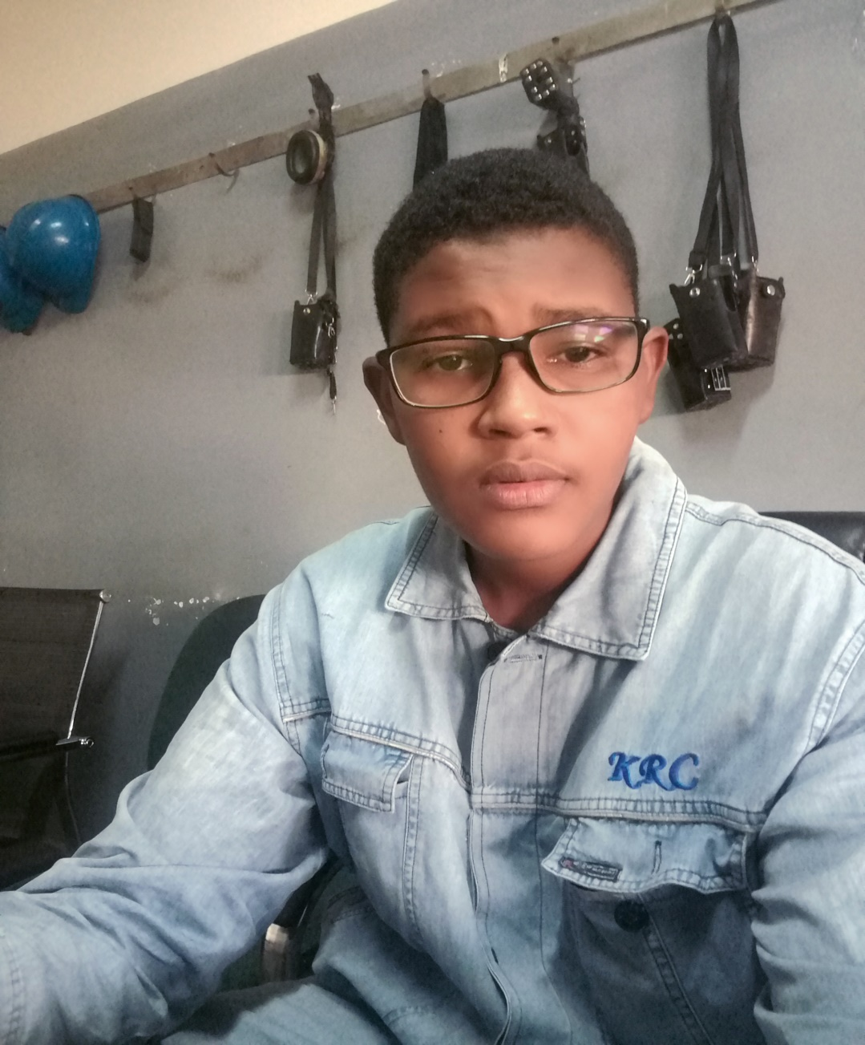

** m7mdelser994@gmail.com**

** +249911090952_+249902499231**

* Good interpersonal communication skills.
* Ability to work under pressure.
* Ability to work in teamwork.
* Easy to adapt to the different situation.

**SKILLS**

I am a field operator in Delayed Coker Unit (DCU) with expertise in Khartoum Refinery Company. I would like to bring my collective experience and success to the feild operator position you are currently advertising, specifically contributing the following to stamper construction:

* Experience in operating & maintaining the equipment.
* Expertise in coke cutting and operating the high pressure pump.

**I would appreciate an opportunity to meet with you to further discuss my operating experience at your earliest convenience.**

**Sincerely,**

**Mohammed Taj Elser**

**CONTACT**

**PROFILE**

**Sudan University of science & technology**

2010 – 2013 Diploma in Petroleum Engineering

**EDUCATION**

**Sudanese petroleum pipelines company**

From 14-09-2015 to 14-09-2016

* Field & panel operation for product pipeline by using pump with v shape diesel engine.

**Khartoum Refinery Company**

From 08-10-2017up to now

* Field operator & coke cutting operator at Delayed Coker Unit.

**COURSES**

* Basic operation course at training center in KRC.
* HSE course at training center in KRC.

**EXPERIENCE**

**MOHAMMED TAJ ELSER**

CURRICULUM VITAE

**Reading**

♫ **Music**

**Khartoum _ Sudan**

**Skype account :mohammedelser994@hotmail.com**

**Travel**

**⚽ Football**

**HOBBIES**