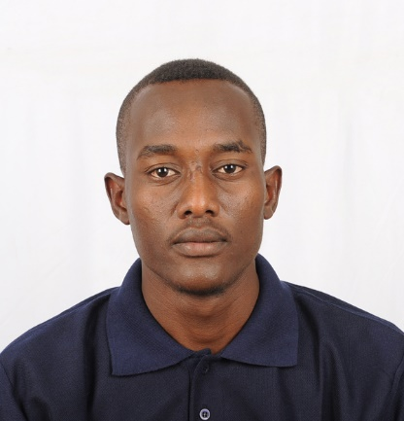
Musleh Mohammed
(FIELD/AOOP OPERATOR)
(Total 04 Years’ Experience)
Email: mslh121@gmail.com
Skype: live: mslh9zaz.
Cell#: 00249919525065
Current Address: Khartoum_ Sudan.
Personal Statement:
I am an enthusiastic and energetic person capable of creative thinking. I get on well with my
colleagues. I work in honest manner and work hard to prove myself as best selected person and I am looking to help companies by working as a Field Operator for them.
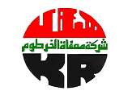
Khartoum Refinery Company .ltd
GDHT & CCR UNITS
(Gasoline Diesel Hydrogen Treatment & Continues Catalyst Reforming Units).
(08-Oct-2017 to up to Date)
KRC One of the largest Sudanese corporation projects in the oil sector, found in 1998 is located 70 km north of Khartoum. The first phase of the refinery was operated with a capacity of two and a half million tons per year. This date of each year is the beginning of production in the refinery.
Six years later, on the thirtieth of July 2006 AD, the second phase of the expansion was successfully operated, and production jumped to five million tons per year at a rate of one hundred thousand barrels per day.

Currently I am working as a field / AOOP operator at Gasoline Diesel Hydrogen treatment & continues catalyst reforming units.
The objective of this_GDHT_ section is elimination of poisonous or undesirable compounds (sulfur, nitrogen, metals, moisture content etc.) contained in the mixed feed stock which contaminate the downstream units’ catalyst and inhibit its selectivity and stability.
Hydro treatment involving hydrodesulphurization and hydrodeenitrification reactions, which are carried out in a fixed catalytic bed axial reactor in presence of hydrogen. GDHT feed is a mixture of Coker naphtha (20%) and Coker diesel (80%). Recycled H2 is mixed with the feed prior to its entering the reactor. The major contaminants like S, N, and O are converted to H2S, NH3 or H2O respectively in the hydro_teater reactor. The liquid product from reactor is then stripped to remove H2S, water, NH3 and light hydrocarbons in a stripper column. The stripper bottom (Hydro- treated Naphtha) is then directly fed to the Reforming Section.
Nominal capacity of the hydro-treater is 1200,000 metric tons per year based on a stream factor 8,000 h/year.

Continuous Catalytic Reforming Unit (CCR) of Khartoum Refinery Company is built under the expansion project of the refinery, phase II. The unit is designed by Sinopec Engineering Incorporation. The process utilizes Axens's "State of the art" moving catalyst bed with continuous catalyst regeneration. The unit is designed to process 400,000 metrics tons per year and to operate at a severity of RON 98 with an on-stream factor of 8000 hours/year.
My Activities on both DCS System of (ABB) and field
including performing productions and unit’s optimization issues, including flushing, blowing
and pressure testing. Good understanding & reading skills about P&ID & PFD.
equipment handover, punch listing, water flushing, lube oil flushing, chemical cleaning, chemical
dosing, steam blowing, air blowing, leak test air freeing, catalyst loading. Normal Start up and
Shutdown of DCS Emergency handling practice on OTS Training (Operator Training simulator).

RESPONSIBILITIES:
• Responsible to monitoring & control over all plant operation and maintain the
operating conditions under desired limits.
• Ensuring safe and smooth operation of the unit. Preparing the daily shift report.
• Coordinating with the Field staff & fully briefed on current status to incoming shift.
• Authorize and co-sign maintenance work permits (PTW).
• Supervision of Maintenance and Electrical job in running plant.
• Carrying out sampling and required laboratory analysis on various streams.
• Preparation of Compressor for maintenance and start-up.
• Preparation of Heaters for firing & Fuel Gas Network (Gas Gathering System)
• Daily monitoring and log sheet filling of Field parameters.
• Attending the departmental safety, health and good housekeeping meetings, participates in
plant inspection tours and takes active participation in implementing Company policies on
safety, health.
MONITERING & TROUBLE SHOOTING:
• Steam Turbine Centrifugal Compressor, Steam Generators.
• Electric Motor Driven Pumps, Steam Turbine Pumps, Multi Stage Pumps.
• Heat Exchangers. Condensers.
• Cooling Tower (ID Fan), Cooling Water System.
• Double stage Double acting Reciprocating Makeup & Recycle Gas Compressor,
• Single Stage Double Acting Reciprocating Recycle Gas Compressor.
• Natural Draft Vertical Cylindrical & Box type Heaters, Reactors.
• Troubleshooting and participating in Start-up & Shutdown of the unit.
• Flare & Flare knock out system

Other Experience:
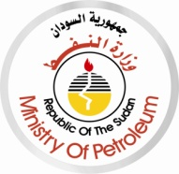 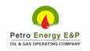 Two Months Experience as field operator (upstream) at ministry of petroleum _ oil exploration & production authority _Sudan, in following field Petro energy Company _ltd, April to September 2014.
The production of oil wells, making sure to provide the appropriate conditions, and conducting preliminary separation of water content in the field station.
Training and courses:
• Basic operation course, Khartoum Refinery Company 2017.
• DCS Simulator for GDHT & CCR.
• HSE Training Program, Khartoum Refinery Company include the following:
• Basic Safety & Environment Awareness.
• Basic Firefighting.
• Documents & Records Control.
• Work Permit.
• Gases Emissions.
• First Aid.
• Emergency Response
• Accidents Investigations.
• Risk Assessment & control Measures.
• Hazards Communication.
• Job Safety Analysis.
• QMS, EMS & OHSAS Standards.
• Internal Audit.

• Training course in personal strategic planning.
Computer & Software’s:
• MS Office pack (Certificate from Alalam alaraby institute).
• Web developer (HTML, CSS, and JS).
• Mobile application developer using (DART & FLUTTER).
• Graphic designer using adobe (PS, AL, AF, PR).

Academic Qualification:
DIPLOMA IN PETROLEUM ENGINEERING, (3 YEARS, GPA 2.76 /4, V.GOOD)
Sudan University of science & technology_2015.

Personal Information:
Name: musleh Mohammed Ibrahim Ismail .
Date of Birth: 10.may 1994
Marital Status: Single
Religion: Islam.
Nationality: Sudanese.
Passport: P08121636.
Languages: English, Arabic.

Social contact:
• LinkedIn: https://www.linkedin.com/in/musleh-mohamed-551554145/

References:
Eng. Mohamed A.kafi.
Production & operation manager / Khartoum refinery company_Ltd.
•Tell: +249912330391.
• Email: mabdelkafi@krcsd.com .
Eng. Mohamed Ali
GDHT & CCR UNITS manager / Khartoum refinery company_Ltd.
•Tell: +249912318966.
Eng. Hozifa alfatih
HSE engineer / Khartoum refinery company_Ltd.
•Tell: +249912149494

Knowledge and skills:
• Arabic & English Language: Fluent written and spoken.
• Working with my colleague as a team work.
• Working under pressure.
• Good team player And Effective communication skills,
• Team spirit and solid on hand.

