PERSONAL INFORMATION | Osman Balla Mohamed Mansoor
[
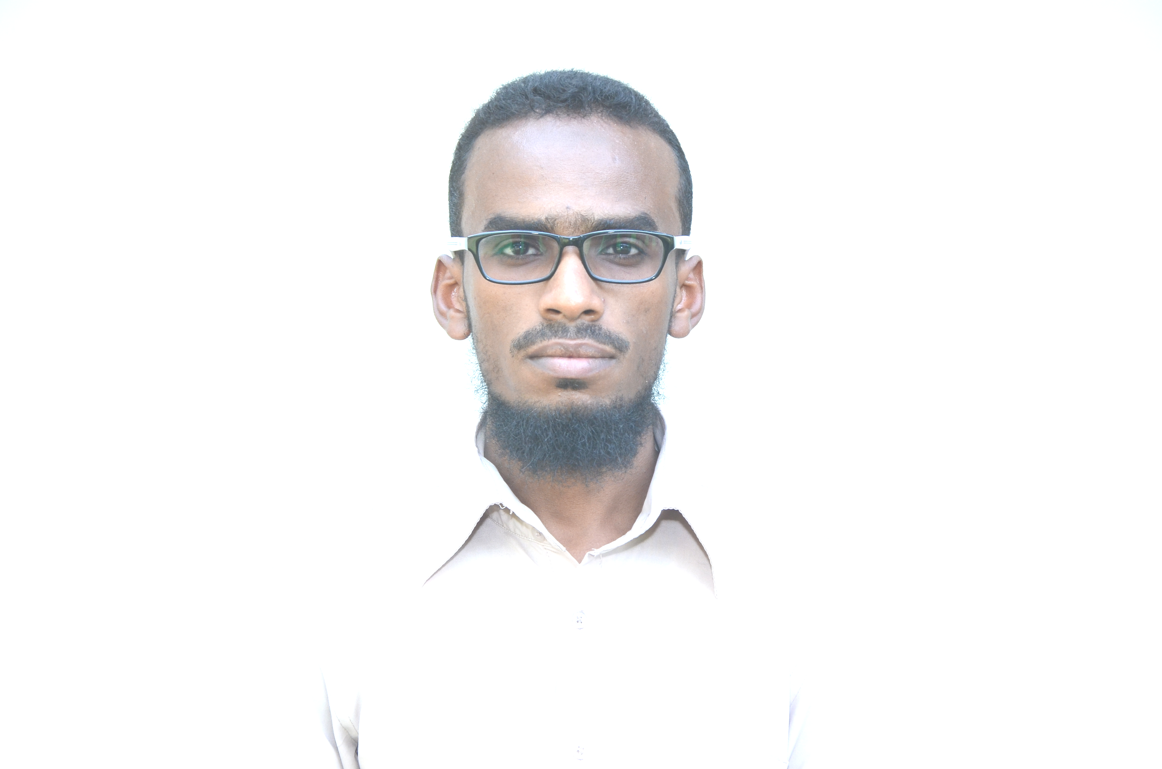 |   JABRA SOUTH14, KHARTOUM , SUDAN

₊₂₄₉₉₁₉₁₀₄₆₄₂

Osman.balla1990@gmail.com
 | Sex MALE | Date of birth 11/5/1990 | Nationality SUDANESE

WORK EXPERIENCE
]
sep (2015 –present) | TEST ENGINEER
sep (2015 –present) | GIAD INDUSTRIAL GROUP
sep (2015 –present) | - Implementation laboratory management system documentation  - Supervision of corrective and pre active actions  - Putting new equipment into operation  - Activities on training and development of junior staff  - Supervision of tacking records during tests  - Checking devices and machines for mechanical testing with small repairs if necessary  - Specific testing in the area of laboratory activity according to customer requirements
sep (2015 –present) | sector Materials mechanical testing

EDUCATION AND TRAINING | Bachelor of Mechanical Engineering-Production  Sudan university of science & technology(SUST)
April18 – may 27.2016 | Polymer composites course
April18 – may 27.2016 | Shriram Institute for Industrial Research . Delhi . India
April18 – may 27.2016 | - Science of composites. Polymers and testing
April 3rd – 4th 2017 | Basic Course testxpert║  Advanced Course testxpert║
April 3rd – 4th 2017 | Zwick GmbH & CO.KG-Head office /Germany
April 3rd – 4th 2017 | - Software for testing materials
10 july -10 sep 2018 | Materials Engineering and Heat Treatment
10 july -10 sep 2018 | Principles training center , Khartoum, Sudan
10 july -10 sep 2018 | - Materials science
12-16 May , 2019 | Statistical tools for metrology practice
12-16 May , 2019 | Nano for Measurement and Calibration Centre ,Khartoum, Sudan
12-16 May , 2019 | - Science of composites. Polymers and testing
22-26 Dec 2013 | OSHA Compliance for General Industry
22-26 Dec 2013 | Charisma Workforce Development, Khartoum ,Sudan
22-26 Dec 2013 | - Safety and occupational health
14-20 oct 2012 | FIRE FIGHTING SYSTEM
14-20 oct 2012 | Soft Star Training Centre, Khartoum ,Sudan
14-20 oct 2012 | - Theory of fighting and systems
15 dec 2021 | NEBOSH IGC
15 dec 2021 | The National Examination Board in Occupational Safety and Health, England
15 dec 2021 | - Safety and occupational health
22-26 Dec 2013 | OSHA Compliance for General Industry
22-26 Dec 2013 | Charisma Workforce Development, Khartoum ,Sudan
22-26 Dec 2013 | - Safety and occupational health
PERSONAL SKILLS
[
Mother tongue(s) | Arabic
otheR LANGUAGES | English

programmes | - AutoCAD  - Solid work

Computer skills | - good command of Microsoft Office™ tools

Driving licence | Level A  `

ANNEXES

- copies of degrees and qualifications;
- experiences
- courses

