Osman Elzain Elshareef Elhassan  Petroleum Engineer  Approved HSE Officer from 2B OPCO  NEBOSH IGC Certified  Citizenship: Sudanese ▪ Date of birth: 1 April 1993  Issued date: 15- july-2022  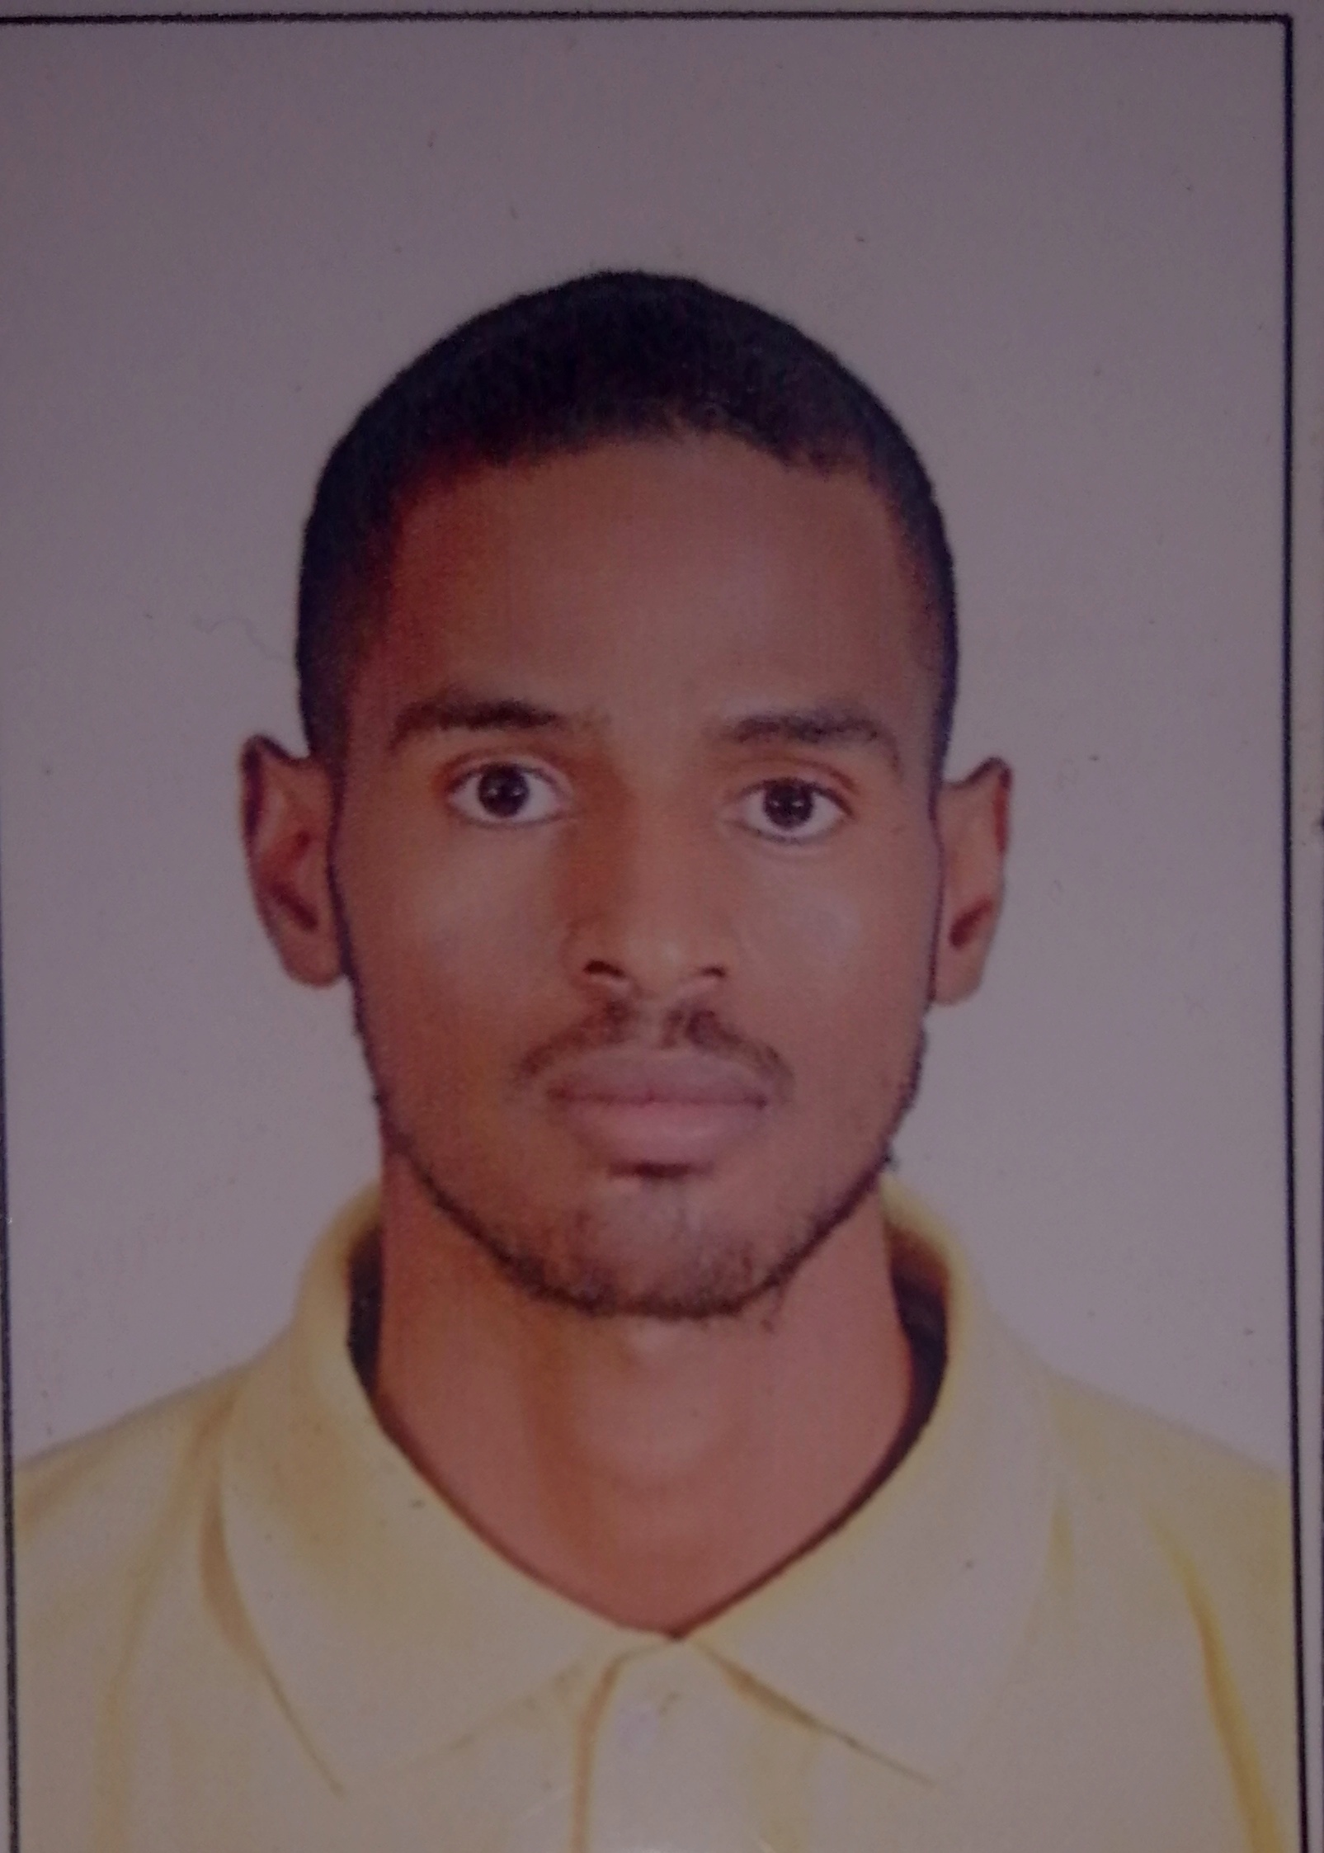  CV. | Contact  Cell phone:-  +249 912674148  +249 118557002  E-mail : osmanalshareef9040@gmail.com
Address
El azhari , Squire 21, House 394, Khartoum , Sudan

Objective
play pivotal role in achieving my employer's corporate objective by supporting and enduring
through professional commitment and integrity, while continuously upholding my personal
ambition of reaching higher scales of accomplishment.

Key Skills
Proficient and/or familiar with a vast array of Petroleum Engineering and HSE field, in addition to personal skills and Computer-literacy.
Engineering and Safety Concepts Commuter and Software Interpersonal Skills
- Management of health and safety  - Risk profiling and risk assessment  - ISO14001 Environmental management system awareness IMS  - ISO9001 quality management system awareness QMS  - Fire inspection  - Fire Emergency action plan  - Drilling Equipment  - horizontal and vertical drilling  - Well control  - Production surface facilities course  - Well stimulation  - Well simulation and CMG module applications | - MS-Office (word power point.)  - Internet.  - MS-excel and data analysis. | - Strong Communication and Interpersonal Skills in both Arabic and English.  - Good team building and work as Individual.  - High Organizational and developing Skills.  - Handling pressure Situation very smoothly.  - Team Management Skills.  - Ability to deal effectively with customers from different cultures.  - Leadership and motivating

Education
2014 to 2020  2021 | Bachelor degree (honor) in Petroleum Engineering (second class upper).  NEBOSH international general certificate in occupational health and safety.

Work Experience
Petroneeds services international PSI. Heglig Projects (August 2021 – present).
Position HSE officer.
Responsibilities:
1- apply safe work permit before every job
2- Apply closing supervision during job
3- Maintaining client HSE standards
4- monitoring unsafe act and unsafe condition
5- carry out daily, weekly, and monthly reports
6- Carry out incident investigation report in case of any incident.
7- reporting directly to HSE Supervisor

Professional Training :-
June 2021 | NEBOSH international general certificate in occupational health and safety IGC
August, 2021 | Fire safety inspection (international training center of international labor organization ITCILO)
August, 2021 | Fire emergency action plan (international training center of international labor organization ITCILO)
May, 2021 | ISO14001: 2015 Environmental management system awareness (the knight of safety institution)
August, 2021 | ISO9001: 2015 Quality management system foundations (the knight of safety institution.

Languages
Arabic (native) | English (Advanced)

References | Position | Company Name
1- Abu Obaida Elzain  Mob #+249 913882153  2- ENG. Ashraf Elzain.  Mob:+249 912131848 | Environmental Engineer  Rig manager | Solar powered pumping project-African development bank  Petroneeds services international PSI

Availability: Available up on request.

