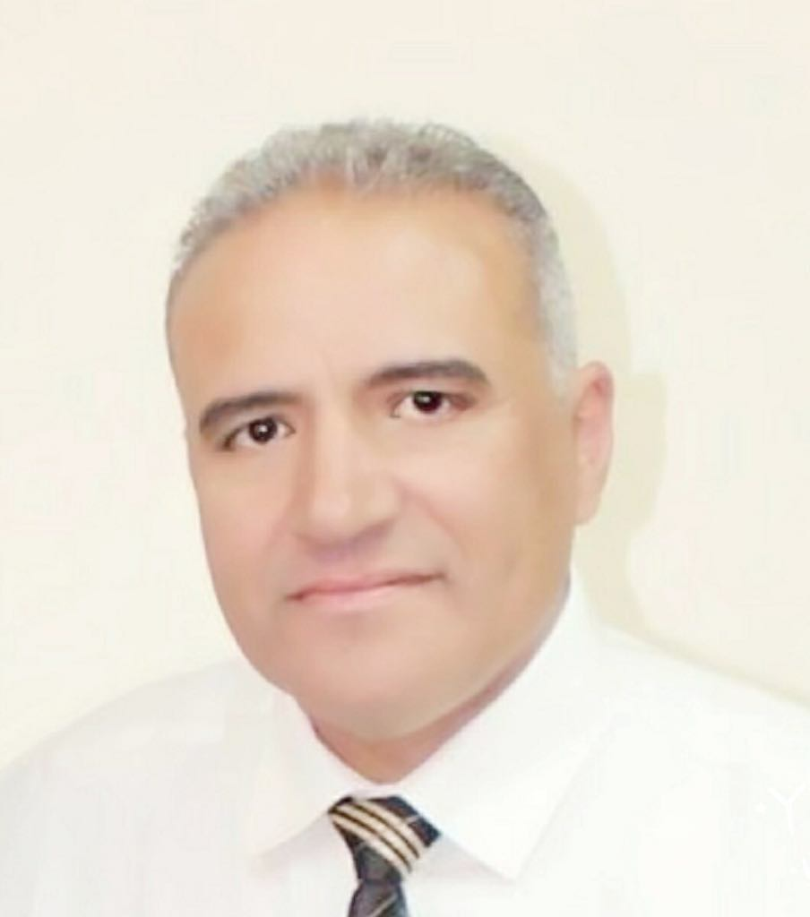

Cairo - Egypt
Mob :- (+ 20) 1002130472
Mob :- (+ 20) 1001614376
E-mail: sayedmeckawy@hotmail.com
Sayed.Meckawy@Eastzeit.Com

Sayed Meckawy

A highly efficient, experienced in oil and gas since 29 years Excellent interpersonal and communication skills development and contracting related to oil and gas field. Enjoying challenging briefs & able to work to an excellent standard under considerable pressure whilst presenting a positive image to managements & colleagues. Looking for opportunity to join challenging company where I can invest my skills, experience and knowledge.

1- Personal Information
Address : Maadi Gardens –district D-2 first up floor. Apartment 2A
Telephone : +201001614376 / + 201002130472 / +2027232464
Nationality : Egyptian
Date of Birth : February 9th, 1961.
Place of Birth : Cairo Egypt.
Military Status. : Completed April 1988.
Passport No. : A19586232 valid until 21/12/2023
Issued Place : Cairo
Issued Date December 2016
Marital Status : Married had 3 Kids.

2- Education
- Name of University: Faculty of engineering Monofia University.
- University Degree: Pass & Project degree very good
- Graduation Year: 1985
- High School: Berket ElSaba secondary school
- - Graduation Year: 1980
- Current Positions : Projects General Manager
- Employer : East Zeit Petroleum. Co., Egypt
- Address : Borg Zahret El Maadi – Cornish El nile-
- Maadi – Cairo - Egypt P.O. Box: 1303
Employment Experience
2014 – till present (East Zeit Petroleum Zeitco )
Projects general manager
Reporting directly to MDs, responsible for reviewing all constructions work carried out by the Projects Dept., including manufacturing, installation and inspection before starting up all constructions, pipelines and production facilities. It is also responsibil for managing the work activities of external contractors, to achieve satisfactory performance in the technical activities, operations and safety.
Duties and Responsibilities
- Build the strong and effective team which can execute the different constructions and preparations of operation upon the appropriate economic way.
- Guide the personnel to abide by the standards of environment, safety and work security.
- Plan and execute the various projects in the limits of job reasonability.
- Perform the affective rule to write and develop the contracts by and between projects, partners, customers and suppliers.
- Follow all important factors which affect the results regarding costs, time schedule, and quality, standards of safety and security and protection of environment as well as informing the team of management, partners and shareholders.
Verify that the project is applying all the principles, procedures and policies of company
- Define and settle all the problems of constructions which may start between the departments of projects, contractors, suppliers to reach the resolutions which could satisfy all parties.
- Share and help in the development of individuals working in project team.
- Responsible for the preparation of project construction costs and program of execution.
- Verify that the standards of comprehensive system of processes administration and instructions of health, safety and environment are completely applied.

From 2013 to 2014 Facility & Maintenance General Manager (East Zeit Petroleum Zeitco)
Duties and Responsibilities
Make sure that all employees in the division perform their work in a safe manner and are committed to security and safety rules as mentioned in the company book.
- Prepare the division budget and make sure of its execution according to the approved items.
-Secure all equipment and instruments also enough spare parts to enable the division perform its responsibilities and duties efficiently and safely, also make sure that the stock of spare parts is available in an economic quantity.
- Put and supervise the executor of the periodical maintenance for equipment with the aim to elongate its lifetime and increase its efficiency, also put the protective maintenance program on the computer.
From 2007 to 2013 Field general manager (East Zeit Petroleum Zeitco)
Duties and Responsibilities
- Totally responsible for all assignments, departments and operations executed in East Zeit and offshore facilities and any other activities in the concession area.
- Run the field with a sound technical and economic way while guaranteeing the safety of personnel and environment from any negative aspects.
- Prepare the annual goals that should be achieved by all divisions under his supervision, follow up execution and revise these goals quarterly with top management
-Make sure that the operations of oil and gas recovery is efficiently done and in a safe way without having a negative effect on personnel, - - environment, equipment and company assets.
- Ensure the safely operating and maintenance of all equipment and instruments of oil and gas production.
- - Responsible for the development and stewardship of the field budget, also the necessary rules to avoid any excess in expenses or deviations in the approved items.
- Supervise all aspects of security and safety in the area; also supervise organizing training courses about security and safety for all employees. Ensure commitment at all times to the regulations of safety in the safety book of the company and other set rules. He is also responsible for the supervision of holding regular safety meetings in all divisions.
- - Supervise the preparation and coordination of employees training programs in the area to improve their supervisory and administrative efficiency.
- Maintain and develop the emergency response plan and make sure that all employees in all sections are fully aware of the comprehensive plans and skillful in taking their role in the plan.
- Supervise the Administration Division in handling its assignments of soundly operating the accommodation area including catering, laundry, entertainment etc. and other services to employees in addition to controlling the medical section to be always ready for the necessary health care in coordination with the medical division in the head office.
- Develop necessary corrective procedures and supervise implementation
- Develop and implement plans for improvement.
- Individual revision between each manager and his subordinates is done separately.

2003 – NOV – FEB 2007 Maintenance Assistant General Manager. (Ocean energy & Seagull Petroleum)
Duties and Responsibilities
Make sure that all employees in the division perform their work in a safe manner and are committed to security and safety rules as mentioned in the company book.
- Prepare the division budget and make sure of its execution according to the approved items.
-Secure all equipment and instruments also enough spare parts to enable the division perform its responsibilities and duties efficiently and safely, also make sure that the stock of spare parts is available in an economic quantity.
- Put and supervise the executor of the periodical maintenance for equipment with the aim to elongate its lifetime and increase its efficiency, also put the protective maintenance program on the computer.
- Maintain all records and files of equipment maintenance to for the maintenance data base.
- Supervise construction work of any approved project and designed by the engineering department and make sure of executing the constructions in accordance with the design.
- Supervise all construction work done by any third party and notify the concerned person in charge upon discovering any deviation of the original specifications.
- - Make sure that all division personnel get the necessary training to use all utilities and fire extinguishers also supervise fire trucks condition in the area.
- Control the sound and safe operating of lifting equipment and heavy equipment designated or used be workers and that it is in accordance with the industry specifications and secure work conditions
- Prepare required reports and presentations about work progress compared to the set plan.
- Set and control execution of the procedures of work steps and inform employees with any new amendments that arise to guarantee improving and developing performance.
- Lead the work group in a modern way aiming at improving and integrating performance and minimize time and charges while entering modern technical technology and follow up it development to guarantee the best use of technology which will reflect on work performance and employees.
- - Make sure that the criteria of the operations integrity management system and health, safety and environment guidelines are applied at all facets of work and that employees and contractors under his supervision are fully aware of them
. - Develop and implement plans for improvement.
- He may be requested to attend meetings or assigned to do work at Cairo office during his vacation.

from 2000 to 2003 Maintenance Department Manager. (Davon Energy)
Duties and Responsibilities
• Contributed In Platform Extension Project.
• Contributed and Supervised Installation Of Jet Pumps.
• Contributing In All Maintenance Programmers (COMAC- GMS)
• Supervised Many Works.
• Responsible for Implementing All Safety Rules and preparing for Safety meeting.
• Responsible For Approving and Applying Permit to Work System
• Responsible of Training All New Hired Engineers and technicians.
1995 to 2000 Maintenance Section Head. (ESSO Suez inc. EXXON)
• Responsible for All Offshore & onshore Maintenance Activities
• Carrying Out All Day To Day Reports And Monthly Reports.
• Preparing monthly performance indicator.
July 1991 to 1995 Maintenance Engineer (ESSO Suez inc. EXXON)
Oil and Gas Production off Shore and Onshore in maintain.
• Generators Gas, diesel Engine, as Caterpillar. Waukesha, commits, Perkins and superior.
• Pumps centrifugal, Diaphragm and reciprocating.
• Compressors Rotating and reciprocating as Ingersoll rand, Atlas copco , Eliot and nova penguin.
• Valves as ball, gate and glop valves.
• High pressure gas turbine Solar
• Share in electrical ad instrument work onshore and off shore.
• Share repairing cooler on shore and off shore.
• Sharing in overhauling engines & compressors
April 88, To July. 91Maintainance supervisor
• Work as Maintenance Engineer for Heavy Equipment Company Samtruck International.
• Work for Same Company Samtruck In China for Almost One Year in Bricks Machine and Heavy Equipment.
• Installed 48 ea bricks fabricating factor machines lines Chinese made in Bricks factors in Egypt as turnkey Started from planning , engineering Study and estimated total cost for (Civil work Mechanical and electrical) until had bricks produced.
Projects completed:
1- Completed Early production facilities project from engineering to execution and operation for 6 ea oil and gas wells with total production 3000 Bbl. oil and 5 MSCF at PetroKareem company.
2- Completed tie-in spool project at Suco gas plant to transfer gas from high pressure to medium pressure started from engineering to execution to stop flaring 3 MSCF daily.
3- Completed 98% of compression gas facilities with 2 km gas pipeline underground isolated at PetroAmer and PetroKareem stop flaring project. Current ongoing total budget 5.7 M$
4- Completed early production facilities at PetroNefertiti at petrobel area with 8 km multiphase line at 2015
5- 99% of permanent facilities at PetroNefertiti and multiphase pipeline 8” Dia. total length 8KM with high technology for remote area using ICS & DCS system current ongoing with total budget 6.2M $.
6- Permanent production facilities at PetroKareem replacing the EPF with total budget 3M $.
Training Courses:
1-Safety& Health (HSE)
Updating my safety passport with all required courses
• Sea Survival in Arab Maritime Transport Academy (Amta)
• Fire Fighting ( Amta)
• Oil Spill (Amta).
• First Aid
• Defensive driving.
• NORM management.
• Helicopter ditching.
• Risk assessment & Risk managements
• Incident investigation.
- Gas safety management’s Randy smith in UK (Newcastle).
2-Technical courses
• Technical Report Writing in AUC
• Pumps and High Pressure Compressors
• Down hole Pumps Esp. In weather ford.
• Simians Turbine in EMC by Siemens international.
• Vibration survey in mechanical equipment

Managerial courses
• Management Skills in AUC.
• Supervisory skills. (Randy Smith).
- Lead course OGS (leadership exultance through awareness & Development)
- Operations safety in Newcastle UK.
- Project management.
- Value Engineering

4- Computer Skills
- Microsoft office Windows (Word, excel & power point)
- Internet Explorer.
- Excellent knowledge of internet usage.
- Adobe Photoshop.
- Office skills (planning, organization, leading).
- Programs related projects MS project , primavera

5- Language
Arabic (native), English (very good), French (poor)

7- Skills
- Ability to work in a team.
- Can learn new technologies.
- Can work under pressure.
- Research abilities.
- Experienced how to treat all workers classes.
- Ability to manage any skills

Cover letter

Dear ,
I am writing to express my interest in working in your company in the position of Job
Title where I can apply and enhance my background, skills, and career through
working in creative and productive development team that aims to meet the company’s
and customers’ requirements and satisfaction. Now I would like to bring my skills and
experience to work for your company.
My current position now Projects General Manager almost 4 years
Work as delegated operations manager for 6 month
Facility & maintenance general Manager 1year
Field general manger almost 7 year
The attached CV can serve to provide you with greater details of my education, skills,
And experience.
Thank you for your time and consideration.
Regards
Sayed Meckawy

